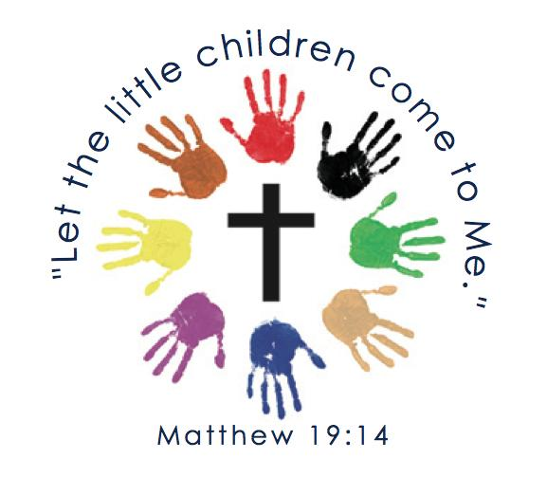

St. Mary – St. Columba Little Lambs Preschool
Washingtonville, N.Y. 10992 Phone 845-496-7221
Our Staff
Pastor: - Father Christopher Argano
Director – Susan Munks Teacher Aides – Miss Kelly 3’s
Teachers – Miss Kim 3’s Miss Isabella 3’s & 4’s
Miss Cara 3’s Miss Maryann 4’s
Miss Eileen 4’s Volunteers – Miss Pat
Miss Teresa 4’s Miss Erica
Miss Val 4’s Miss Marie

St. Mary-St. Columba Little Lambs Preschool Program is dedicated to providing social, emotional, spiritual, physical and academic growth; within a Catholic setting. Our goal is to provide a program that develops age-appropriate activities for our children in a safe and nurturing environment.
Three -Year -Old Program (3rd birthday on or before December 1st of the school year)
Your child should be toilet trained or in the process (Pull-Ups only). Our program for three-year olds focuses on socialization skills, following classroom routines, sharing, making friends, cleaning up, and becoming more independent. Prayers are taught and the liturgical calendar of the Church is followed in an age-appropriate manner. Academically the program will work on colors, shapes and name recognition as well as introduce the alphabet and numbers.
Four-Year-Old Program (4th birthday on or before December 1st of that school year)
The goal of the four-year-old program is to prepare your child for kindergarten. The children will review colors and shapes and more fully learn the alphabet and numbers, as well as learn to write their name, letters and number. Prayers are said daily and the liturgical calendar of the Church is followed in an age-appropriate manner. Fostering independence is key to success in kindergarten.

Our staff is CRP/First Aid/AED trained. Our center is clean and bright.
Call today to schedule a tour!
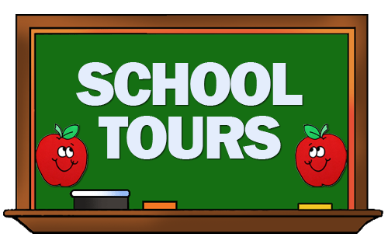
Susan Munks
845-496-7221

